
HPM/HCM v3.7.7.8
Customer Release Notes
October 2023

We have designed this guide to help you understand the recent changes and updates to the Helix Practice Manager / Helix Consultant System. We recommend you take the time to read this guide after your upgrade is completed. Please contact our Customer Support Department if you have any queries regarding the upgrade on 01-4633098 or email: gpsupport@clanwilliamhealth.com.

Table of Contents
Pippo 2
New STC Codes 3
Flu Season 2023 4
Cycle of Care Change 6

Pippo
Pippo icon added to Appointments when the HPM Pippo service is running. User can click Portal to launch the Pippo Portal. On the Portal, user can configure their Pippo settings e.g. appointment types, portal availability etc. Customers can contact support to organise getting this installed
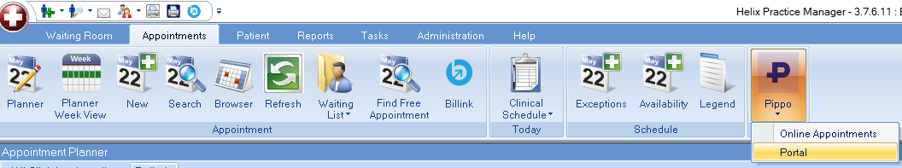

User can view all online appointments which have been accepted / declined.
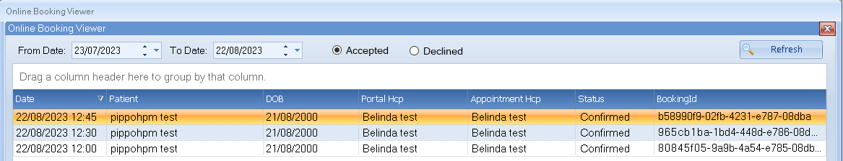
- Date: Date the original appointment was requested by the patient.
- Portal HCP: HCP requested by the patient.
- Appointment HCP: HCP the appointment is currently assigned to.

Created By on the Appointment summary shows ‘Received via Online Booking’.
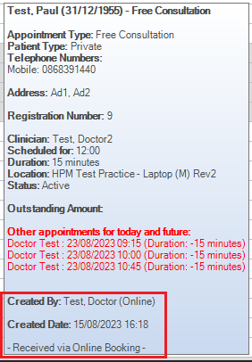

Pippo Registration
Patients can be registered directly from Patient Registration once the Pippo Service is installed. The user can click ‘Not Registered’. They will receive a prompt if the patient does not have a mobile number or email address entered as these are mandatory.
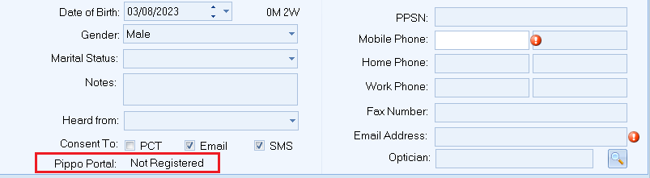
Once the patient has an email address and a mobile number user will be presented with the Send Invite window.
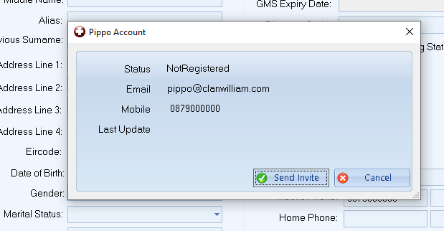
Once the invitation has been sent the details are saved to the database and the status will update to InviteSent. The patient will receive an email with a link to complete their registration and choose a password for their account. They will have to enter the verification code sent to their mobile.
After successful verification the status will update to Verified.

New STC Codes
New STC codes added for Contraception Services – CL, CN, CO & CQ.
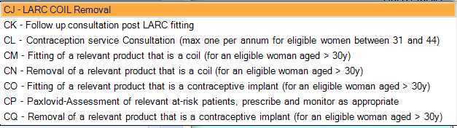

Flu Season 2023
Vaccine changes for flu season
- Flu & Pneumococcal: Auto select ‘Age 65 & older’ if patient falls into this age category.
- Flu: Auto select ‘Age 2 to 12 years’ risk factor if patient falls into this age category.
- Flu: Age 2 to 17 years risk factor removed.
- The patient’s age & risk factor will be rechecked if the date of administration is altered to ensure the risk factor is still applicable. If it is not, the user will be returned to the risk factor screen to select a new risk factor.
HPM-2088 Removal of expired batches
- Batches for previous flu season deactivated.
- Covid RTU Pfizer – FR9178 deactivated.
Flu Season 2023/2024 Batches
New vaccine and batches added for 23/24 flu season – G28, G25, TH2109.
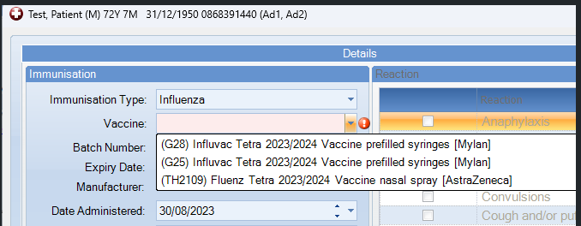
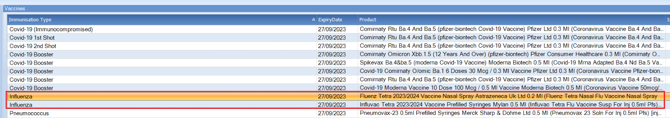
Influenza only - add in new risk factor ‘Adult with immunocompromised respiratory function’
New risk factor for ‘Adult with immunocompromised respiratory function’ added for Influenza Vaccines.
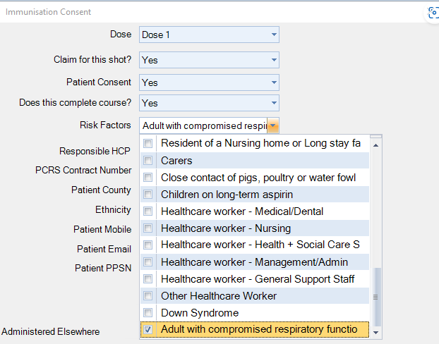
Auto select Pregnant risk factor if patient has an active pregnancy
Pregnant will be auto selected as a risk factor when adding an Influenza vaccine if the patient has an active pregnancy.
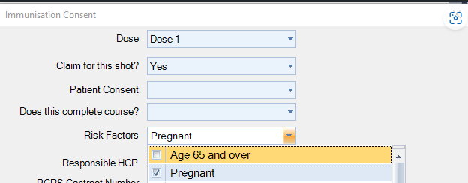
Flu & Pneumococcal – Auto-select Immunosuppressed risk factor if IC Assessment at primary vac or after primary vac is selected in custom field
Immunosuppressed risk factor auto selected if the patient has and IC Assessment of ‘IC after primary vaccination’ or ‘IC at time of primary vaccination’ selected in patient demographics.
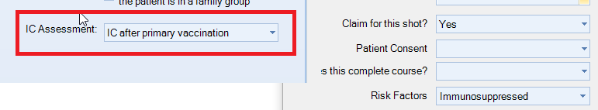
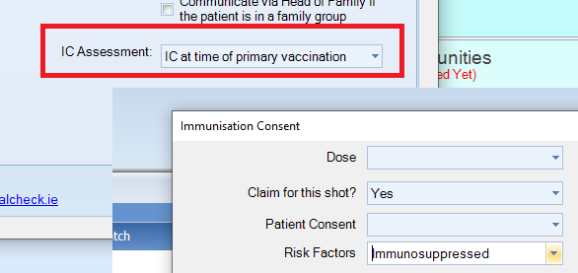

Cycle of Care Change
Asthma Assessment: Increase age from under 6 to under 8
Age increased from Age 6 to Age 8.

